• Overview & Scope (existing)
- Purpose, scope, audience, tools, versioning, storage (Confluence/Git), retention policy.
Overview & Scope
Purpose: The Phishing Email Analysis and Response Playbook aims to establish a standardized, repeatable, and efficient process for identifying, analyzing, and responding to phishing attempts targeting the organization’s users, assets, and communication channels. Phishing remains one of the most prevalent initial access vectors in cyberattacks, often serving as the entry point for credential theft, ransomware deployment, and business email compromise (BEC).
This playbook provides a structured framework to ensure that every reported or detected phishing email is handled consistently, efficiently, and in compliance with the organization’s security and privacy requirements.
The primary objectives are to:
- Reduce the time to detect, triage, and respond to phishing incidents.
- Ensure that false positives are identified early to minimize disruption.
- Standardize the technical and procedural workflow for SOC analysts and IR teams.
- Strengthen user awareness and promote proactive reporting of suspicious emails.
- Improve threat intelligence collection and feed updates with validated Indicators of Compromise (IOCs).
- Enable auditability and continuous improvement of phishing response processes through proper documentation and version control.
This document is not limited to incident handling but also supports training, quality assurance, and compliance validation for cybersecurity governance frameworks such as ISO 27001, NIST SP 800-61r2, and CIS Control 13.
Scope
This playbook applies to all organizational email accounts and systems connected to the enterprise email environment—both on-premises and cloud-based (e.g., Microsoft 365, Google Workspace). The scope covers phishing events reported by employees, detected automatically by email security gateways (SEG), or flagged through the SOC’s SIEM or EDR solutions.
In-scope activities include:
- Receiving and triaging reported or automatically detected phishing emails.
- Performing detailed analysis of email headers, content, URLs, and attachments.
- Executing static and dynamic analysis of potentially malicious payloads using sandbox environments.
- Identifying associated IOCs (hashes, IPs, domains, URLs) and submitting them to internal threat-intel repositories.
- Containing the threat by blocking sender domains, quarantining emails, or isolating affected endpoints.
- Communicating with affected users, IT operations, and management throughout the response lifecycle.
- Generating incident reports and lessons learned for continuous improvement.
Out-of-scope activities include:
- Threat hunting and proactive campaign analysis beyond confirmed phishing incidents.
- Forensic investigations of large-scale compromises, which are handled under the Incident Response and Digital Forensics Playbook.
- Security awareness training content creation (though this playbook provides technical feedback for training programs).
The scope applies globally across all business units and subsidiaries. Any deviation or local adaptation must be approved by the Cybersecurity Governance Board.
Audience
The intended audience for this document includes:
- SOC Analysts (Level 1 and Level 2): Responsible for triaging alerts, analyzing suspicious emails, performing sandbox analysis, and escalating confirmed incidents.
- Incident Response (IR) Team: Responsible for containment, eradication, recovery, and coordination with external stakeholders when a phishing campaign results in compromise.
- Security Engineering & Threat Intelligence Teams: Responsible for maintaining detection rules, integrating automation workflows (SOAR), and enriching IOCs.
- IT Operations and Email Administrators: Support containment actions such as domain blocking, rule updates, and mail quarantine management.
- Compliance, Legal, and PR Teams: Provide guidance on regulatory notification requirements and communication strategies in the event of a breach.
- Executive Management: Require high-level situational awareness and reporting metrics on phishing trends and response effectiveness.

Tools and Technologies
This playbook relies on a combination of security technologies and collaboration platforms to ensure end-to-end visibility and coordinated response:
- Email Security Gateway (SEG): For automated filtering, quarantine management, and header inspection.
- Security Information and Event Management (SIEM): For correlation of phishing indicators and alert prioritization.
- Endpoint Detection and Response (EDR): To isolate affected hosts and confirm payload execution attempts.
- Sandbox / Detonation Platform: For behavioral analysis of suspicious attachments and URLs (e.g., Any.Run, Cuckoo, or built-in M365 Defender sandbox).
- Threat Intelligence Platform (TIP): For enrichment and sharing of IOCs (e.g., MISP, OpenCTI).
- SOAR (Security Orchestration, Automation and Response): To automate repetitive tasks such as IOC enrichment, email deletion, and user notification.
- Collaboration & Documentation Tools: Confluence for documentation, Jira or ServiceNow for ticketing, and Slack/Teams for internal coordination.
- Analytical Utilities: URLScan.io, VirusTotal, and internal PowerShell or Python scripts for rapid header and URL parsing.
Versioning and Document Control
Version control is essential to ensure that the playbook remains accurate, auditable, and traceable over time.
- The master document is maintained in Confluence under the Cyber Defense Operations space.
- Each update is tracked through the built-in page history with version tags following the format vX.Y (e.g., v1.0 – Initial Release, v1.1 – Updated URL Analysis Procedure).
- Major revisions (X) require formal review and approval by the Cybersecurity Governance Board and the SOC Manager. Minor revisions (Y) may be approved by the SOC Lead.
- Git repositories are used for storing automation scripts and JSON/YAML workflow files referenced by the playbook. Each commit must include a clear message indicating purpose, date, and author.
- Archived versions older than 12 months are moved to the “Historical Playbooks” folder in Confluence but remain accessible for audit purposes.
Storage and Accessibility
All playbook documents, analysis templates, and IOC datasets are stored securely in Confluence and mirrored in Git for resilience. Access is role-based:
- SOC Analysts and IR staff have read/write permissions for operational sections.
- Engineering teams have write permissions for automation and tooling modules.
- External contractors or auditors are granted read-only access under a non-disclosure agreement (NDA).
Data backups are performed nightly, and the integrity of stored files is verified monthly using SHA-256 checksums. Access logs are retained and reviewed quarterly by the Security Operations Manager to detect unauthorized access or modification attempts.
All storage locations must comply with the organization’s Information Classification and Handling Policy. No sensitive data (PII, credentials, or malware samples) shall be uploaded to third-party cloud platforms without explicit approval.
Retention Policy
Proper data retention is critical for regulatory compliance, forensic readiness, and continuous improvement. The following retention standards apply to all artifacts generated during phishing investigations:
Artifact Type | Retention Period | Storage Location
Playbook Documents (Confluence) | 3 years from last update | Confluence / Secure Drive
Automation Scripts & SOAR Workflows | Active + 1 year | Git Repository
Ticketing Records (Jira/ServiceNow) | 2 years | Ticketing System
Sandbox Reports & Analysis Logs | 12 months | Internal Secure Share
IOCs (MISP/STIX Feeds) | 24 months, then reviewed | Threat Intel Platform
Email Samples (.eml, headers, attachments) | 6 months unless needed for ongoing investigation | Isolated Secure Repository
Audit & Access Logs | 18 months | SIEM / Log Archive
Summary
This Overview & Scope defines the operational boundaries, responsibilities, and data-management practices for the Phishing Email Analysis Playbook. By enforcing clear documentation standards, tool integration, and versioning discipline, the organization ensures consistent, defensible, and high-quality handling of phishing incidents.
Continuous review, automation, and training based on lessons learned will sustain the effectiveness of this playbook as phishing tactics evolve. The principles outlined here form the foundation for trust, traceability, and measurable improvement in the organization’s cybersecurity posture.
Level 1 (L1) SOC Analyst — First line of defense
Primary purpose (big picture):
Be the fast, accurate filter: stop obviously malicious emails, preserve critical evidence, classify incidents properly, and ensure appropriate escalation so fewer incidents become major breaches.
Detailed day-to-day responsibilities
- Monitoring & intake
  - Watch inbound channels continuously: Phish button, user reports, SEG quarantines, SIEM alerts.
  - Triage every new report within SLA (see SLA table).
- Initial technical checks (quick checklist — aim: 5–10 min)
  - Open original .eml (never forward body copy). Save .eml to evidence store.
  - Check header basics: From, Return-Path, Received, SPF/DKIM/DMARC quick result.
  - Inspect sender display name vs actual address; look for homoglyphs or extra characters.
  - Does the email contain a link or an attachment? Copy link (do NOT click) and note file type.
  - Apply the priority matrix: targeted exec? contains payload? mass campaign?
- Preservation
  - Save .eml, take screenshots (mail client + headers view), capture URL text, hash attachments, forward sample to sandbox per playbook rules.
  - Tag ticket with initial evidence attachments and analyst name.
- Containment (fast actions L1 can take)
  - For clear mass campaigns or known phishing: submit block request to SEG or apply quarantine rule (if authorized).
  - For obvious credential phishing (link-only) with high confidence: add to proxy blocklist and update incident ticket.
- Communication
  - Notify reporter with standard templated reply: what we saw, actions taken, do’s/don’ts.
  - If escalation needed, include summary + evidence package for L2.
- When to escalate to L2
  - Attachment with suspicious file type or sandbox score > threshold.
  - Targeted BEC impersonation or payment request.
  - Confirmed or suspected credential compromise.
- Common pitfalls
  - Deleting the original .eml or modifying message before saving header.
  - Clicking links or opening attachments in a non-sandbox environment.
  - Under-classifying priority for an exec-targeted mail.
Deliverables & documentation
- Completed triage checklist in ticket.
- .eml + screenshots + copied suspicious URLs + initial risk justification.
Level 2 (L2) SOC Analyst — Deep triage and containment
Primary purpose:
Provide expert analysis: validate L1 findings, run deeper enrichment, trigger containment across tools, and decide if full IR activation is required.
Detailed tasks
- Deep technical analysis
  - Run headers through auto-parsers; map full Received chain and geolocation of originating IP(s).
  - Submit URLs to URLScan/VirusTotal/Any.run; review redirect chains and capture screenshots.
  - Submit attachments to sandbox (playbook: submit → wait verdict → extract artifacts).
  - Correlate indicators with SIEM: any logins from suspicious IP? lateral activity?
- Threat scoring & decision
  - Use scoring rubric (example: SPF fail = +8, DKIM fail = +12, attachment with macro = +15). If score > auto-block threshold, perform auto actions or recommend IR.
- Containment actions L2 can perform
  - Push EDR block for file hash, add proxy deny rule for URL/domain, create SEG rule to quarantine similar messages, block SMTP/IP on perimeter firewall (with approval).
  - Freeze affected mailbox or disable forwarding rules if thread compromise suspected.
- Interaction with IR
  - If there is evidence of account compromise or endpoint execution, escalate to IR immediately with complete evidence bundle and recommended containment.
- Handover to IR
  - Include timeline, all IOCs (hashes, URLs, domains, IPs), affected users, sandbox reports, and SIEM correlation findings.
- Post-action
  - Propose lasting detection rules (YARA, mail gateway signatures), and ensure updates to phishing training or blacklists.
Common pitfalls
- Acting on partial sandbox results (some sandboxes return delayed behavior). Wait for conclusive verdict or annotate uncertainty.
- Blocking broadly (e.g., whole legitimate domain) without impact analysis.
Incident Response (IR) Team — Contain, eradicate, recover
Primary purpose:
Lead the response when the phishing incident has real impact (compromised account, malware execution, or data exposure).
Phases & tasks
- Initial response (first 15–60 minutes)
  - Triage confirmation: confirm scope (number of users, systems), isolate compromised endpoints (EDR isolate), disable compromised accounts.
  - Preserve forensic images / EDR snapshots before remediation steps that alter state.
- Forensic investigation
  - Timeline reconstruction: email arrival → link clicked → credentials used / binary executed → lateral movement.
  - Pull endpoint telemetry, authentication logs, proxy logs, mailbox audit logs, and any pcap if available.
- Containment
  - Revoke active sessions, reset credentials, enforce MFA, block C2 domains, quarantine affected hosts.
- Eradication & recovery
  - Clean or rebuild endpoints, restore mailboxes from safe points, reissue credentials and rotate secrets, verify backups.
  - Implement temporary mitigations: network segmentation, elevated monitoring, lockouts.
- Coordination
  - Run bridge calls with L2, Legal, Comms, and Execs as required. Keep a live incident timeline document.
- Post-incident
  - Produce full incident report: timeline, root cause, impact, remediation, lessons learned, suggested permanent fixes.
Evidence chain & chain of custody
- Document where evidence is stored, who accessed it, and timestamps for each action (important for legal/regulatory needs).
Common pitfalls
- Remediating before acquiring necessary forensic evidence (losing root cause).
- Failing to coordinate with Legal/PR early when there’s any chance of data exposure.
Legal / Compliance — Regulatory & contractual guardrails
Primary purpose:
Make sure response actions meet laws, contracts, and privacy obligations; prevent regulatory missteps.
Detailed responsibilities
- Assess obligations
  - Determine breach notification requirements (local laws, regulatory bodies, contracts).
  - Confirm timelines for notifying regulators, customers, or impacted individuals.
- Advise on communications
  - Review and approve messaging (internal and external). Ensure language does not admit liability beyond facts.
- Coordinate with law enforcement
  - When financial loss, fraud, or large exposure occurs, advise on contacting law enforcement and preserving evidence.
- Support evidence needs
  - Provide advice on legal hold, eDiscovery, and chain of custody procedures.
Operational touchpoints
- Be part of the IR bridge if P1 incidents indicate potential reportable breach.
- Provide a legal contact person who is on-call for incident windows.
Common pitfalls
- Not reacting fast enough when regulations require notification within a short window.
- Providing public statements without IR/L2 technical clearance.
Communications / Public Relations (PR) — Message control
Primary purpose:
Protect reputation and provide clear, timely messaging to employees, customers, partners, and press — coordinated with Legal.
Detailed responsibilities
- Internal comms
  - Prepare user-facing templates (phishing confirmations, guidance on password resets, suspicious link reporting).
  - Deliver consistent instructions through corporate channels (email, intranet, Slack).
- External comms
  - Draft press statements or customer notifications only after Legal sign-off.
  - Manage media relations and FAQs, and act as the central point for external inquiries.
- Tone & content
  - Avoid overly technical language for broad audiences; be transparent about impact and steps users need to take.
- Coordination
  - Maintain pre-approved boilerplate messages for common scenarios (credential theft, mass phishing, confirmed breach).
- Common pitfalls
  - Releasing messages that cause panic or unnecessary admission.
  - Not aligning timing with Legal and Execs leading to mixed messages.
Executives / Management — Decision & escalation owners
Primary purpose:
Authorize business-critical responses and be briefed on impact, cost, and legal obligations.
Detailed responsibilities
- Decision making
  - Approve large-scale containment (e.g., shutdown of services) or public disclosures.
  - Provide cross-functional support and resources for remediation.
- Stakeholder communication
  - Be briefed for regulatory reporting, board updates, and customer notifications.
- Prioritization
  - Decide acceptable business risk and sign off on remediation timelines that affect operations.
Common pitfalls
- Delayed acknowledgement or decisions on P1 incidents.
- Overcorrecting (drastic operational shutdowns) without full situational awareness.
Practical checklists
L1 Quick Triage Checklist
- Save original .eml to evidence store
- Screenshot headers and message body
- Copy all URLs (do NOT click)
- Note attachment types and hash (if present)
- SPF/DKIM/DMARC quick result
- Assign priority (P1–P4) + reason
- Escalate to L2 if needed; attach evidence
L2 Investigation Checklist
- Parse full headers and map Received chain
- Submit URLs to URLScan/VirusTotal
- Submit attachments to sandbox; extract artifacts
- Correlate with SIEM/auth logs
- Recommend containment and/or escalate to IR
- Document IOCs and update ticket
IR Containment Checklist
- Isolate affected host(s) (EDR)
- Disable/lock compromised accounts; revoke sessions
- Preserve forensic images & logs
- Implement temporary network blocks
- Plan eradication & recovery steps

Communication Matrix
1 | Purpose of Communication | Type of Message | Recipient | Channel / Tool | Example
L1 SOC Analyst | Confirm receipt of phishing report | User Acknowledgement | Reporting user | Email / Teams | “Thanks for reporting. We reviewed your email and classified it as [P#]. Do not click any links.”
L1 → L2 | Escalate suspicious or confirmed phishing | Escalation Header | L2 SOC Analyst | Ticketing system / Email | “URGENT — P1 Phishing Escalation. Reporter: [user]. Evidence: [.eml]. Action requested: deeper analysis.”
L2 SOC Analyst → IR Team | Notify and request incident handling | Incident Escalation | IR Team | Email / Bridge Call | “Confirmed phishing with credential compromise. IR engagement required for containment.”
IR Team → Legal / PR | Inform of confirmed compromise or data exposure | Status Update | Legal & PR Teams | Teams / Email | “Phishing incident may involve data exposure. Legal review and PR coordination needed.”
IR Team → Executives | Report major incidents / request decisions | Executive Briefing | Executive Management | Email / Call / Meeting | “Targeted phishing on executive account contained. Approval required for disclosure.”
Legal → PR | Review or approve external communication | Legal Review Request | PR Team | Email | “Please submit your public statement draft for legal review before release.”
Legal → Authorities / Regulators | Mandatory reporting if required by law | Incident Notification | Regulatory Body / Authority | Official email / portal | “We are reporting a phishing-related incident detected on [date], affecting [#] accounts.”
PR Team → Employees | Internal awareness or guidance | Internal Notice / Advisory | All staff | Email / Intranet / Slack | “Phishing campaign detected. Report similar emails via the Phish button. Do not click links.”
PR Team → Customers / Media | External communication or statement | Public Notification / Press Release | Clients / Media / Public | Email / Website / Press | “A phishing attempt was detected and contained. No customer data was compromised.”
Executives → SOC / IR / Legal | Decision making and authorization | Approval / Directive | SOC / IR / Legal Teams | Email / Meeting | “Approve immediate password reset for all impacted users and coordinate public notice.”
Understanding Phishing Detection Sources
Detection of phishing emails involves a combination of proactive monitoring, user involvement, and automated alerting systems. Each source contributes unique insights, helping security teams identify threats before they escalate. Here's a breakdown of the key sources mentioned:
- Phish Button in Mail Clients: These are user-friendly tools integrated into email clients like Outlook or Gmail, allowing employees to report suspicious emails with a single click. For example, KnowBe4's Phish Alert Button enables safe forwarding of emails to security teams for analysis, reducing the risk of accidental engagement. Similarly, Proofpoint's PhishAlarm simplifies reporting to abuse boxes, often triggering automated workflows. In Splunk environments, a "Report suspected phishing email" button connects directly to SOAR for ingestion, emphasizing user empowerment in detection. Best practices include training users to recognize phishing indicators like urgent language or unfamiliar senders, ensuring reports are routed efficiently to minimize false positives.
- SEG Alerts: Secure Email Gateways act as the first line of defense, scanning incoming emails for malicious content, links, or attachments. They generate alerts based on signatures, heuristics, or machine learning. In investigations, SEG logs help confirm email delivery and quarantine status. For instance, Microsoft Defender for Office 365 uses SEG-like features to flag phishing, integrating with broader tools for alert generation. These alerts are often noisy, requiring correlation with other sources for accuracy.
- EDR Alerts: Endpoint Detection and Response systems monitor device-level activities, alerting on behaviors like attachment execution or unauthorized processes stemming from phishing. CrowdStrike's Falcon Insight XDR ingests endpoint data to detect post-click activities, while Swimlane SOAR uses EDR for quarantining compromised endpoints. Prophet Security highlights correlating EDR telemetry with email logs to verify interactions, such as link clicks or file opens. This source is crucial for confirming compromises beyond initial email receipt.
- Proxy Logs: These capture network traffic, revealing connections to malicious URLs or domains from phishing links. Microsoft recommends forwarding VPN/proxy logs to SIEM for analysis, while Prophet Security uses them to track user interactions like outbound requests. In fast-moving incidents, proxy logs provide timestamps and IP details, aiding in scoping the "blast radius" of an attack.
- User Reports: Beyond phish buttons, manual user submissions to dedicated mailboxes or portals are common. ServiceNow automates incident creation from these reports, while Splunk and Swimlane ingest them via monitored mailboxes for triage. Encouraging reporting through awareness programs ensures timely detection, though it can lead to volume overload without automation.
- SIEM: Security Information and Event Management systems aggregate logs from various sources to detect patterns indicative of phishing, such as unusual email traffic or login attempts. SearchInform's SIEM analyzes logs for malicious links, while CrowdStrike's Falcon Next-Gen SIEM uses correlation rules aligned with MITRE ATT&CK. SOC Prime's ecosystem integrates SIEM with email data for threat hunting. Optimization involves focusing on high-value logs to reduce noise.
To illustrate, the following table summarizes these detection sources, their primary functions, and example tools:
Detection Source | Primary Function | Example Tools/Integrations | Potential Challenges
Phish Button (Mail Client) | User-initiated reporting of suspicious emails | KnowBe4 Phish Alert, Proofpoint PhishAlarm, Splunk Report Button | High false positive rates from untrained users
SEG Alerts | Scanning and alerting on email content/headers | Microsoft Defender for Office 365, third-party gateways | Noisy alerts requiring triage
EDR Alerts | Monitoring endpoint behaviors post-interaction | CrowdStrike Falcon Insight XDR, general EDR systems | Limited to devices with agents installed
Proxy Logs | Tracking network connections from phishing links | VPN/proxy integrations with SIEM | Requires log forwarding for analysis
User Reports | Manual submissions to security teams | ServiceNow, Swimlane monitored mailboxes | Volume management and verification
SIEM | Aggregating and analyzing logs for patterns | CrowdStrike Falcon Next-Gen SIEM, SearchInform | Overwhelm from uncorrelated data
Ingestion Mechanisms: From Detection to Actionable Response
Ingestion mechanisms bridge detection to response, automating the flow of phishing data into security systems. The specified process—automatic .eml saving → ticket creation → evidence storage—aligns with industry workflows.
- Automatic .eml Saving: Emails are often saved in .eml or .msg formats for preservation. Splunk SOAR ingests these via connectors like MS Graph for Office 365, labeling them as "email" artifacts for analysis. Swimlane automates ingestion from mailboxes, parsing into structured fields. In ThreatConnect, phishing mailboxes enable automated .eml ingestion. This step ensures forensic integrity, with tools like Intezer parsing emails for threats.
- Ticket Creation: Once ingested, systems create tickets for tracking. ServiceNow's playbook automates incident creation from user-reported phishing, applying filters and workflows. Swimlane generates IT tickets for remediation, while CrowdStrike SOAR triggers workflows for investigations. This centralizes response, reducing manual effort.
- Evidence Storage: Data is stored in secure repositories like SIEMs or data lakes. Microsoft exports logs to Sentinel for retention, while ServiceNow configures evidence file storage with previews and downloads. SOC Prime links to data lakes for long-term hunting. Best practices include timestamping and hashing for chain-of-custody.
The ingestion flow can be visualized in a phased table:
Phase | Description | Tools Involved | Best Practices
Automatic .eml Saving | Capture and parse email in standard format | Splunk SOAR, Swimlane, ThreatConnect | Use polling intervals (e.g., 30 min)
Ticket Creation | Generate incidents/tickets from ingested data | ServiceNow, CrowdStrike SOAR | Apply filters to reduce duplicates
Evidence Storage | Securely archive data for analysis and compliance | Microsoft Sentinel, ServiceNow Storage | Ensure export to external SIEM for retention
Parsers and Connectors for SOAR: Enabling Automation
SOAR platforms orchestrate responses by parsing data and connecting systems. Parsers extract elements like headers, attachments, and IOCs, while connectors facilitate data flow.
- Parsers: IBM's Python script in QRadar SOAR parses inbound emails, extracting content for tasks. Swimlane parses emails into fields like subject and IOCs. Splunk uses playbooks for parsing .eml files in sandboxes.
- Connectors: CrowdStrike offers out-of-the-box connectors for email ingestion, supporting 10GB/day free. Google Security Operations uses IMAP Email connectors. Medium articles note connectors for Gmail/Outlook in SOAR playbooks. ReversingLabs integrates with Splunk SOAR for email triage.
- Pseudo-Connectors: These are custom or simulated integrations for testing, such as scripted APIs mimicking real connectors. Reddit discussions on CrowdStrike Fusion SOAR describe pseudo setups for extracting URLs from emails to IOCs. IBM scripts serve as pseudo-parsers for custom environments. Best practices involve no-code builders for rapid deployment.
A comparison table of SOAR tools:
SOAR Tool | Key Parsers/Connectors | Pseudo-Connector Examples | Use Case Focus
Splunk SOAR | MS Graph for Office 365, IMAP; parses .eml for IOCs | Custom playbooks for simulation | Automated email triage and sandboxing
CrowdStrike Falcon Fusion | Out-of-the-box for email/EDR; API-based parsing | Scripted workflows for URL extraction | Phishing investigation and MTTR reduction
Swimlane | Email parsing into fields; integrations with EDR/IT tickets | Fuzzy hashing for matching | Phishing triage and remediation
IBM QRadar SOAR | Python scripts for email parsing | Sample scripts as pseudo-parsers | Inbound email processing
In practice, combining these elements reduces mean time to respond (MTTR), with automation handling 79% of incidents in some dashboards. Organizations should align with MITRE frameworks, test integrations, and monitor KPIs like false positives and throughput for continuous improvement.

Triage Decision Tree — Phishing Email Analysis Playbook
Purpose: The Triage Decision Tree defines the structured logic followed by SOC analysts and automation systems (SOAR) to determine whether a phishing email should be auto-blocked, escalated for manual review, or dismissed as benign. It ensures fast, consistent, and accurate decision-making to minimize risks and human error.
Flowchart Overview
Below is the visual representation of the triage process. Each decision node defines whether the case follows an automated (Auto) or human (Manual) branch.
▼ Flowchart: Triage Decision Flow (Auto vs Manual) ▼
Start → Email Received
↓
Attachment Present? → Yes → Sandbox Scan → Malicious? → Auto Block
│
→ No → Link Present? → Yes → URL Analysis → Malicious? → Auto Block
│
→ No → Target Executive? → Yes → Manual Review (L2)
│
→ No → Compromised Account? → Yes → Auto Block + IR Escalation
│
→ No → Calculate phish_score → ≥ Threshold? → Auto Block else → Manual Review (L1)
↓
End → Ticket Closed / IR Engaged

Auto vs Manual Decision Branches
Condition | Branch Type | Example Action
Malicious attachment detected | Auto | Block sender + quarantine message
Known bad domain or IP | Auto | Add to blocklist + EDR hash block
Executive or sensitive user targeted | Manual | Escalate to L2 analyst
Unclear sandbox result | Manual | Human review required
Confirmed account compromise | Auto | Auto block + notify IR team
SOAR Implementation — phish_score Logic
The SOAR system assigns a phish_score to each email based on multiple indicators. If the score exceeds a threshold (e.g., ≥ 50), automatic containment is triggered. Otherwise, the email is routed for manual triage.
Indicator | Score Weight | Description
SPF Fail | +10 | Possible spoofed sender
DKIM Fail | +10 | Tampered email signature
Malicious Attachment | +20 | Executable or macro-enabled file
Credential Phishing Link | +15 | Login form detected
Targeted Executive | +10 | High-value target indicator
Known IOC (hash/domain) | +25 | Confirmed malicious intelligence
Summary
This decision tree forms the foundation of phishing triage automation. It ensures repeatable, auditable, and effective handling of phishing incidents by combining automated intelligence with human verification where necessary. The visual flow and logic tables guide SOC analysts to maintain consistency and precision during incident response.

Concept of a Sandbox in Malware and Link Analysis
A malware sandbox is essentially a virtual, isolated environment designed to execute and observe potentially malicious files, code, or links without risking damage to the host system or network. It acts like a digital quarantine zone, simulating real-world conditions (such as operating systems, browsers, or applications) to monitor behavior, network activity, file changes, and other indicators of compromise. This isolation prevents malware from spreading or interacting with actual resources. In the context of link analysis, sandboxes can "detonate" URLs by loading them in a controlled browser to detect phishing, drive-by downloads, or exploit kits.
Use Cases for Sandboxes
Sandboxes are widely used in cybersecurity for scenarios where untrusted content needs safe evaluation. Key use cases include:
- Malware Detection and Analysis: Running suspicious executables, scripts, or attachments to observe behaviors like registry modifications, file drops, or command-and-control (C2) communications.
- URL and Link Investigation: Analyzing potentially malicious links from emails or websites to identify redirects, malware downloads, or web-based threats without exposing the real system.
- Threat Intelligence Gathering: Security Operations Centers (SOCs) use them to dissect new threats, generate indicators of compromise (IOCs), and inform defenses.
- Software Testing and Development: Testing unverified code or applications in a safe space to check for vulnerabilities or unintended behaviors.
- Incident Response: Quickly assessing files or links from reported incidents to determine if they're benign or harmful. They're particularly valuable for high-volume automated scanning in enterprise security tools or for manual deep dives by analysts.
Steps Involved in Sandbox Analysis
Sandbox analysis can be divided into automated (hands-off, script-driven) and manual (interactive) steps. The process typically starts with submission and ends with reporting. Here's a breakdown:
Automated Steps
These are efficient for bulk processing and rely on pre-configured rules or scripts to handle detonation.
- Submission: Upload the file, URL, or sample to the sandbox via API, web interface, or integration (e.g., from email gateways).
- Environment Setup: The sandbox provisions a virtual machine (VM) with a specified OS (e.g., Windows 10), applications, and monitoring tools.
- Detonation/Execution: Automatically run the sample—execute files or load links in a browser—while logging activities like API calls, network traffic, and system changes.
- Monitoring and Data Collection: Use hooks or agents to capture behaviors (e.g., via Sysmon or network sniffers) for a set duration (often 1-5 minutes).
- Analysis and Reporting: Generate automated reports with IOCs, behavior scores, and verdicts (e.g., malicious/benign) using built-in heuristics or ML models.
- Cleanup: Reset the VM to prevent persistence.
Manual Steps
These allow analysts to interact for deeper insights, especially with evasive or complex samples.
- Initial Automated Run: Start with an auto detonation to get a baseline report.
- Interactive Session: Log into the VM (e.g., via VNC or web console) to manually trigger actions, like clicking links, entering credentials, or simulating user behavior.
- Real-Time Monitoring: Observe live processes, debug with tools like Process Explorer, or capture packets with Wireshark inside the sandbox.
- Behavioral Tweaking: Adjust VM settings (e.g., change time zones or add decoy files) to evade anti-sandbox techniques.
- Reverse Engineering Integration: Export artifacts for further static analysis outside the sandbox.
- Documentation and Export: Manually annotate findings and export data for sharing or correlation.
For link-specific analysis, steps focus on browser automation: loading the URL, monitoring HTTP requests, and checking for exploits.

Accuracy in Detection or Analysis
Sandbox accuracy varies but is generally high for behavioral detection, often exceeding 70-90% for known malware families by focusing on runtime actions rather than signatures. However, limitations exist:
- Strengths: Excels at identifying polymorphic or zero-day threats through dynamic analysis; ML integration boosts precision.
- Weaknesses: Advanced malware can detect and evade sandboxes (e.g., via VM artifacts like low RAM or specific drivers), leading to false negatives. Studies show evasion rates up to 30% in basic setups. False positives can occur with benign but unusual software. Overall, accuracy improves with hybrid approaches (static + dynamic) and anti-evasion features, but no sandbox is 100% foolproof—benchmarks like Pafish test evasion resistance.

Comparison Between a General/Local Sandbox and ANY.RUN
A general or local sandbox (e.g., open-source like Cuckoo Sandbox) runs on your hardware or private infrastructure, while ANY.RUN is a cloud-based, interactive service. Here's a comparison:
Aspect | General/Local Sandbox (e.g., Cuckoo) | ANY.RUN
Setup and Accessibility | Requires local installation, VM hypervisors (e.g., VirtualBox), and configuration; more effort but customizable. | Web-based; no setup needed—upload and analyze via browser. User-friendly interface for quick starts.
Interactivity | Mostly automated; manual interaction possible but requires custom scripting or tools. | Highly interactive—real-time control over the VM (e.g., mouse/keyboard simulation) for manual triggering of behaviors.
Supported Platforms | Flexible; supports multiple OS (Windows, Linux, Android) with extensions. | Primarily Windows-focused; limited to common configs but fast for typical threats.
Scalability and Speed | Scalable locally but resource-intensive; analysis can take longer without cloud power. | Fast (90% of analyses in ~60 seconds); cloud-scaled for high volume.
Cost and Privacy | Free/open-source; full data privacy as it's on-prem. | Freemium model (limited free tier); data processed in cloud, potential privacy concerns for sensitive samples.
Features | Strong for automation and integration (e.g., with SIEM); community-driven. | Advanced visuals, threat hunting, and community reports; better for SOC collaboration.
Evasion Resistance | Varies; basic setups vulnerable, but customizable anti-evasion. | Good built-in evasion countermeasures; ML-enhanced detection.
Local sandboxes suit privacy-focused or custom needs, while ANY.RUN excels in ease-of-use and speed for quick investigations.

Performing Analysis Without a Sandbox and Relevant Tools
Yes, you can perform malware and link analysis without a sandbox using static analysis (examining without execution) or reputation-based checks. This avoids runtime risks but misses behavioral insights, so it's best for initial triage. Key tools include:
- For Static Malware Analysis:
  - PeStudio: Scans PE files for anomalies like imports, strings, and entropy.
  - Ghidra or IDA Pro: Reverse engineering for disassembling binaries and understanding code logic.
  - YARA: Rule-based scanning for patterns in files.
  - Process Monitor (ProcMon) and Autoruns: Track system changes or autorun entries without full execution.
  - Strings or Binwalk: Extract embedded strings or files from binaries.
- For Link/URL Analysis:
  - VirusTotal: Scans URLs against multiple engines for reputation; also handles files (note: VT uses sandboxes internally but you don't manage one).
  - URLScan.io or Sucuri SiteCheck: Analyzes link redirects, content, and blacklists without loading.
  - Wireshark or Fiddler: Capture and inspect HTTP traffic from safe proxies (e.g., manual curl requests).
  - Phishtank or URLhaus: Community-driven databases for known malicious links.
- Hybrid/Other Tools:
  - Process Hacker: Monitors processes and threads statically.
  - ProcDOT: Visualizes process relationships from logs.
  - CISA Malware Next-Gen: Free U.S. government platform for automated static/dynamic scans (web-based, no local sandbox needed).
These tools are often free/open-source and focus on non-execution methods, reducing risks but requiring expertise for accurate interpretation. For comprehensive results, combine with sandboxes when possible.
Email Header
The email header is the DNA of the message… It tells you:
- Who sent it?
- From where?
- Who did it pass through?
- Where was it edited?
- How was it forwarded?
- Was it forged?
- Did the systems accept the message or reject it?
The header is divided into 3 main levels:
- Envelope Headers (SMTP Layer)
- Message Headers (Mail Layer)
- Metadata & Internal Headers
Envelope Header: Return-path / Received “servers” / DKIM / DMARC / SPF
Message Header: From / To / Subject / Reply-to / Date
Metadata header: This is the info that Mail Servers and Security Tools add like : Message-ID / X-Originating-IP “original sender IP” / X-mailer “Program” / MIME-Version “Type of content : HTML - Text”
How do I access the email header?
From Gmail (web):
- Open your email.
- Click the three dots in the top right corner.
- Select Show Original.
- You'll see a full page containing:
- Header
- SPF/DKIM/DMARC
- Message Body.You'll also find a Download Original button to download it as an .eml file if you're going to analyze it.
From Outlook (web):
- Right-click on the message → Message Options. You'll find the header at the bottom.
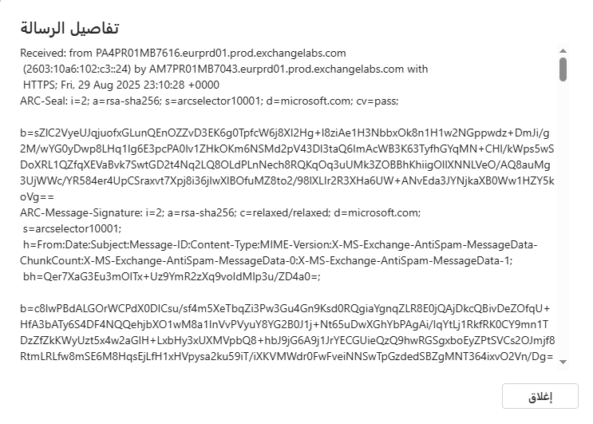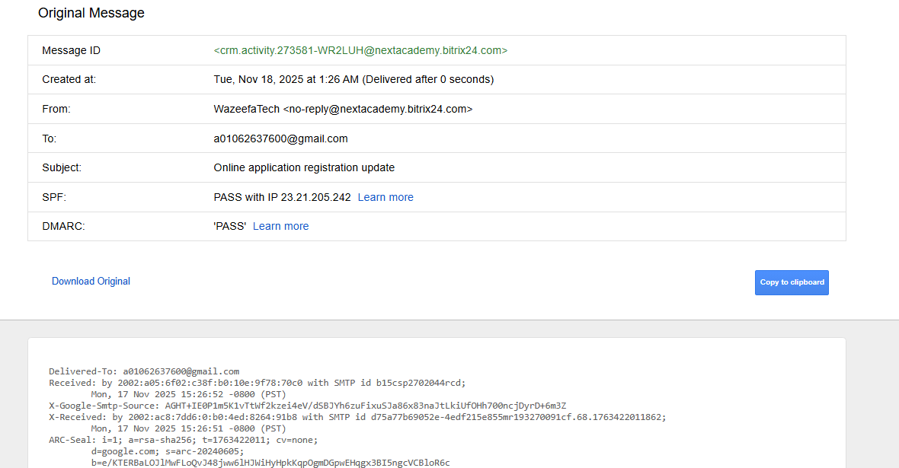
Gmail
Outlook

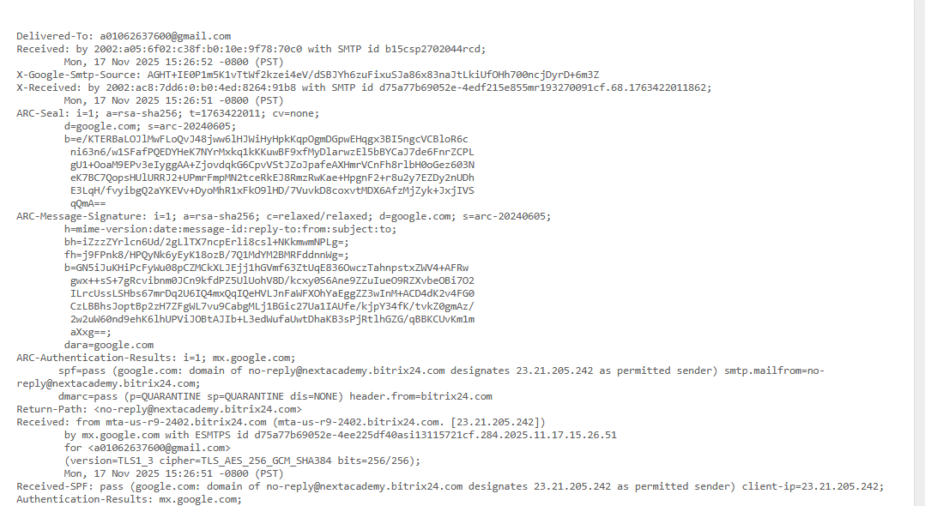 SPF = PASS : SPF : Sender Policy Framework This is a protocol that determines: Which servers are allowed to send emails with your domain name , The Return-Path must always match the SPF.
DKIM = PASS : DKIM : DomainKeys Identified Mail This is a cryptographic signature.
ARC = PASS : ARC = Authenticated Received Chain This ensures that the message was passed through a trusted intermediary server.
DMARC policy : Domain-based Message Authentication, Reporting & Conformance = QUARANTINE = If the message fails in SPF or DKIM → it will be marked as spam.
Any fail mean there is a problem
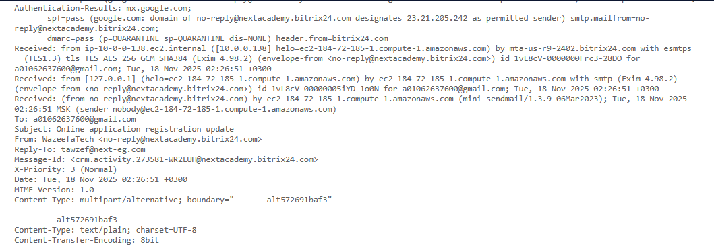
ec2-184-72-185-1.compute-1.amazonaws.com
Sent using: Exim 4.98.2 TLS 1.3 Cipher: TLS_AES_256_GCM_SHA384 ..Exim 4.98.2 is a version of Exim Mail Transfer Agent (MTA). It's a program responsible for sending and receiving messages.
X-Priority This is the email header that determines the message's priority. Example of possible values:
1 or High → High priority
3 or Normal → Normal priority
5 or Low → Low priority
MIME Short for Multipurpose Internet Mail Extensions. Its function: It allows email to support: Text in various formats (plain text, HTML) Attachments Images, audio, video, and more Before MIME, email only accepted plain ASCII text.
Demarc problems
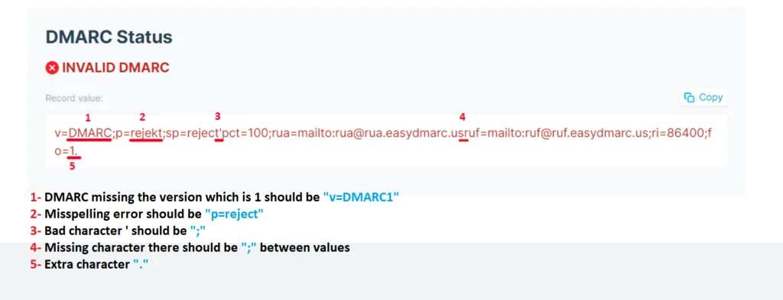

Tools
  - Google Admin Toolbox
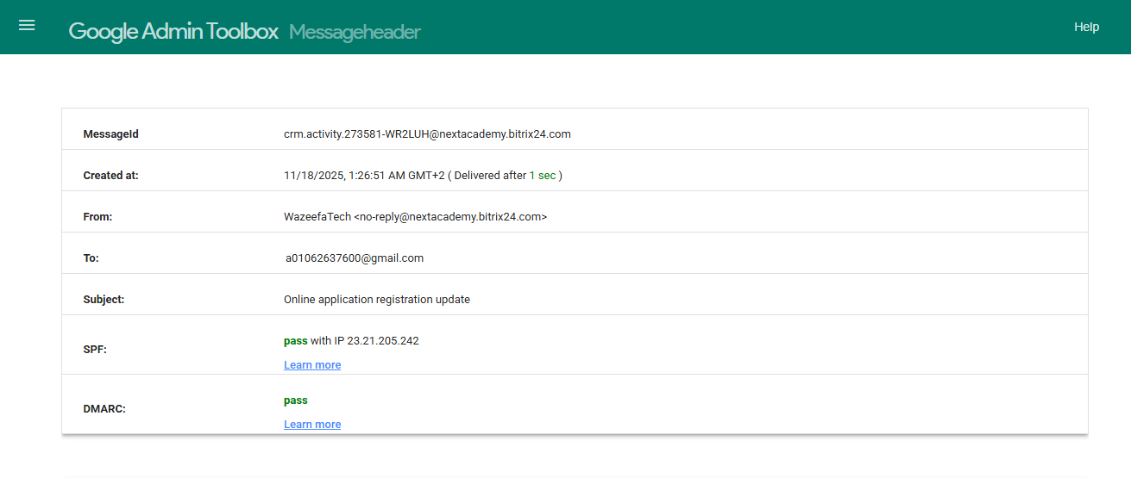
  - MX Toolbox
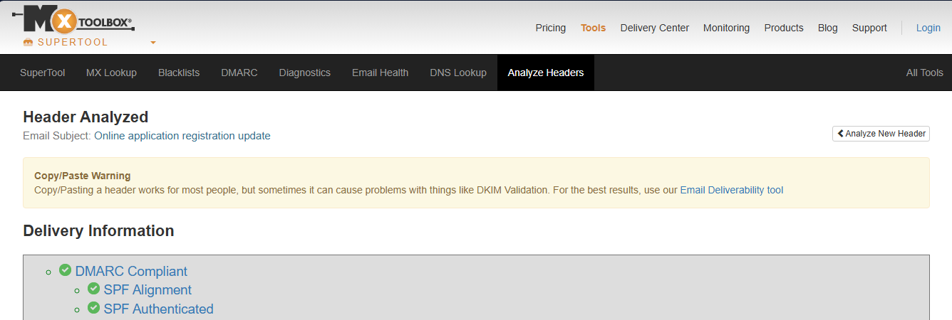
  - Check IP reputation (Talos / AbuseIPDB / VirusTotal “URLs”)
  - Search for anomalies (weird mailer, timezone mismatch, strange servers)

Credential Harvesting (Link-Only) Phishing :
What is Credential Harvesting (Link-Only) Phishing?
Credential harvesting is a phishing technique in which attackers send emails containing malicious URLs that redirect victims to fraudulent login pages designed to steal credentials for systems such as Microsoft 365, VPN portals, HR platforms, banking systems, or cloud applications.
Unlike malware-driven phishing, these attacks contain no attachments—the entire operation depends on convincing the user to click a link and willingly enter their username, password, or MFA code.
Attackers often imitate trusted brands (Microsoft, Adobe, HR tools), exploit urgency (“Your mailbox will be deactivated”), and use convincing replica login pages. Credential harvesting frequently leads to account takeover, internal BEC attacks, MFA bypass attempts, data theft, and lateral movement, making it one of the most dangerous entry vectors in enterprise environments.
Indicators of Compromise (IoCs) for Credential Harvesting
Indicators help identify early signs of a credential-harvesting attempt in email, user behavior, and network activity.
Indicator | Description
Suspicious or Lookalike URLs | Domains resembling legitimate services (e.g., micros0ft-login.com, onedriv3-secure.net). May use Punycode or URL shorteners.
Mismatch Between Link Text & Actual URL | Hyperlink displays “View Document” but redirects to unrelated domain.
Fake Login Pages | Replica Microsoft 365/Azure portals hosting on unknown or newly registered domains.
Shortened or Obfuscated Links | Use of t.ly, bit.ly, rebrand.ly, TinyURL to hide malicious destinations.
Multiple Redirect Chains | Redirecting through several hops before landing on phishing page.
SPF/DKIM/DMARC Failures | Spoofed sender domain failing authentication checks.
Urgent Email Themes | “Password expires in 24 minutes”, “Verify your account”.
External Branding Imitation | Fake SharePoint, OneDrive, or DocuSign notifications.
User Reports Entering Credentials | Confirmed or suspected user interaction with fake login page.
Unusual Login Attempts | Sign-ins from new locations, TOR, VPS, or impossible-travel events following the phishing email.
Additional indicators: suspicious HTML attachments containing hidden redirect links, URL parameters containing encoded user email, device alerts showing browser redirections, or OAuth consent requests immediately after link click.
Triage Checklist
Use this checklist to validate & scope credential-harvesting incidents:
- Create an incident ticket, acknowledge user report, and preserve the original email (.eml).
- Review email content and headers (SPF/DKIM/DMARC, sender domain, link format).
- Extract URLs safely (copy, never click) and analyze using URLScan, VirusTotal, or internal TI.
- Check user interaction:
  - Did the user click?
  - Did they enter credentials?
  - Did MFA prompt unexpectedly appear?
- Search for IoCs: URLs, sender domain, IPs, redirection domains.
- Check account activity (Microsoft Entra ID):
  - Sign-ins from unusual countries
  - Concurrent sessions
  - Impossible travel
  - Successful/failed MFA events
- Check mailbox adjustments:
  - Inbox rules
  - Forwarding rules
  - Delegated permissions
- Look for additional victims by email distribution list or SIEM query.
- Determine compromise method and confirm scope (credential entry, lateral movement).
- Escalate to IR if credential compromise is confirmed.

Containment Strategies (Automated vs Manual)
Containment prevents further misuse of stolen credentials and stops propagation of the phishing campaign.

Automated Containment
• Auto-block malicious URLs/domains
- Through email gateways, proxy, or firewall deny-lists.
- Automatically triggered after URLScan/VT verdict → SOAR updates blocklists.
• Automated quarantine of all matching emails
- Secure Email Gateways (Defender 365, Proofpoint, Mimecast) can retroactively delete similar messages.
• EDR / Identity Protection automation
- Suspicious login → auto-disable sessions
- Impossible travel → auto-trigger MFA reset or password reset
• SOAR workflows
- Enrich indicators → update proxy/SEG blocklist
- Notify SOC channels
- Create IR incident if account activity is abnormal

Manual Containment

Microsoft 365 / Entra ID (PowerShell Commands)
Disable account immediately
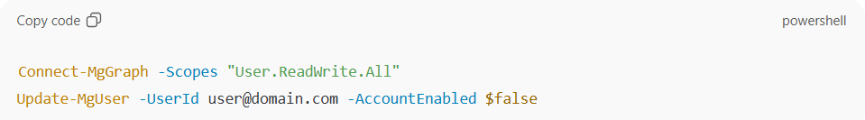
Revoke all active sessions
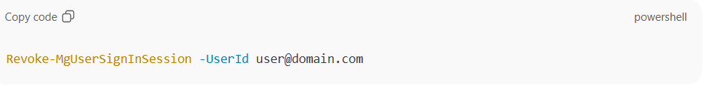
Reset password (force change at next login)
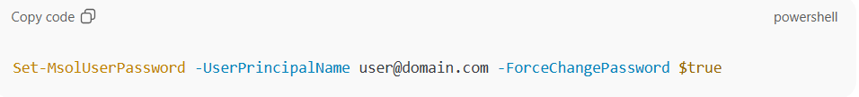
Remove forwarding rules
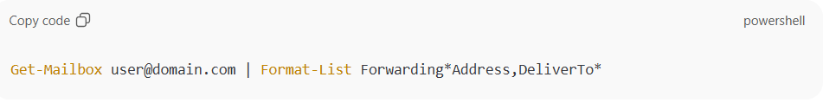
Remove malicious inbox rules
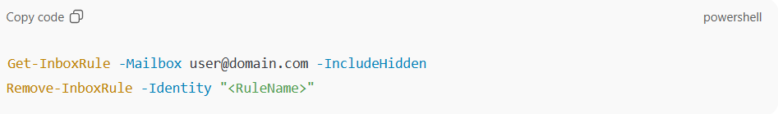
Email Gateway Actions
• Block sender domain
• Quarantine all related emails
• Enable ZAP (Zero-hour Auto Purge) to remove variants

Endpoint Containment
• Isolate machine if malware download occurred after link click
• Preserve browser history, downloads, cookies for forensics
Eradication & Recovery

Eradication
• Remove malicious inbox rules, forwarding, and delegated mailbox access.
• Revoke OAuth consent & remove unknown enterprise apps.
• Reset password for affected users (cloud + on-prem AD if hybrid).
• Clear session tokens and refresh tokens.
• Enforce MFA re-registration to avoid token theft or AiTM persistence.

Recovery Steps
• Password Reset
- Strong password enforcement
- Double reset for AD Connect
- Ensure user verifies all active sessions afterward
• MFA Enforcement
- Remove old authentication methods
- Add new MFA device
- Enforce phishing-resistant MFA (FIDO2 / Authenticator App)
• Mailbox Restore
- Restore deleted items if attacker cleaned Inbox/Sent
- Restore mailbox to a clean point-in-time (Acronis / Veeam / M365 native recovery)
• System Hardening
- Review conditional access policies
- Enforce risky IP blocking
- Disable legacy authentication
Evidence to Collect
• Original phishing email (.eml), full headers, and body.
• URL samples + redirected domains + HTML source of phishing pages.
• Attachment (if HTML/HTM used for redirection).
• Browser logs: downloads, session cookies, form submission cache.
• Microsoft Entra sign-in logs (IPs, device IDs, MFA attempts).
• Audit logs: mailbox rule creation, forwarding rules, delegated permissions.
• Proxy logs showing outbound requests to phishing domains.
• Hashes or artifacts if malware was delivered post-click.
• User interview notes for confirmed credential entry.

Post-Incident Reporting & Lessons Learned (Metrics, MISP Export)

Lessons Learned
• Identify training gaps (user clicked? entered credentials?)
• Determine detection gaps (SEG allowed email? Proxy allowed URL?)
• Improve automation (SOAR enrichment, blocklists, conditional access)
• Verify MFA resilience (phishing-resistant vs OTP-based)

Metrics
- Time-to-detect (MTTD)
- Time-to-contain (MTTC)
- Number of compromised accounts
- Number of emails delivered vs blocked
- User reporting rate vs click rate
- Block rate after SOC actions (URL/domain)

MISP Export
Upload as a MISP event containing:
• Malicious URLs
• Redirect chain domains
• Hosting IP addresses
• HTML templates from phishing kit
• Email metadata (sender domain, return-path)
• User-agent strings captured from phishing portal
• Classification tags (Phishing, Credential Harvesting, O365, Kit-Name)
Testing & Exercises (Detection & Training)

Detection Testing
• Test conditional access policies preventing login from high-risk locations.
• Validate proxy URL filtering using controlled phishing test links.
• Test SIEM rules for impossible travel / MFA fatigue.
• Execute SOAR simulation using benign test URLs.

Training & Campaigns
• Conduct simulated phishing emails containing realistic login prompts (SharePoint, OneDrive, HR Portal).
• Conduct exercises targeting executives and finance (who are high-risk).
• Use role-based simulations:
- IT staff → fake admin portal login
- HR → fake CV portal login
• Conduct tabletop exercises covering account takeover scenarios.

Malicious Attachment (Macro / Exploit) Phishing :
What is Malicious Attachment (Macro / Exploit) Phishing?
Malicious Attachment phishing refers to email-based attacks where the threat actor sends weaponized files—such as macro-enabled Office documents, PDFs containing embedded scripts, compressed archives, or exploit-based payloads—to infect a user’s system or gain initial access.
Unlike credential-harvesting emails that rely on URLs, these attacks focus on execution of malicious content on the user’s endpoint, often leading to malware infections, remote access Trojans (RATs), keyloggers, ransomware, or data exfiltration.
Attackers typically disguise these attachments as invoices, payment notices, resumes, delivery documents, HR files, or internal reports to appear legitimate. Once opened, macros or exploits trigger scripts (PowerShell, WMI, MSHTA, CMD) that download malware or connect to Command & Control (C2) servers.
These attacks commonly deploy malware families like AgentTesla, Formbook, Qakbot, Emotet, AsyncRAT, LokiBot, and can serve as the first stage for ransomware operations.
Indicators of Compromise (IoCs) for Malicious Attachment Phishing

Indicator | Description
Macro-Enabled Files | Attachments with .docm, .xlsm, .pptm, .rtf, .vbs, .js extensions prompting the user to “Enable Content.”
Suspicious File Extensions | Double extensions (e.g., invoice.pdf.exe), .iso, .img, .zip with executable content.
Unusual Attachment Types | .hta, .chm, .lnk, .scr, .bat disguised as documents.
Password-Protected Archives | ZIP/RAR attachments with passwords inside the email to bypass antivirus scanning.
Fake or Repetitive Filenames | “Invoice_2024”, “Payment_Copy”, “DHL-Delivery-Receipt”, often shared across campaigns.
Abnormal Email Themes | Finance/HR-related requests, unsolicited invoices, resumes, job applications, shipment notifications.
Sandbox / AV Flags | File hashes flagged by VirusTotal, ANY.RUN, or internal TI.
Behavioral Indicators | Attachment triggers PowerShell, WScript, MSHTA, regsvr32, cmd.exe, or drops secondary payloads.
New C2 Communications | Endpoint connects to unknown IPs/domains after opening attachment.
EDR Alerts | Suspicious process trees, privilege escalation, registry changes, or persistence mechanisms.
Additional indicators include metadata anomalies (document created by unknown user), malicious VBA obfuscation, embedded OLE objects, or exploitation of CVEs like CVE-2017-11882 (Equation Editor).
Triage Checklist
Follow these steps to evaluate and classify malicious attachment incidents:
- Create and assign incident ticket; save and upload original .eml and attachments to evidence store.
- Do NOT open the attachment locally, even in preview mode.
- Hash the attachment using SHA-256 and check TI sources (VirusTotal, Hybrid Analysis).
- Submit file to sandbox (ANY.RUN, Cuckoo, Defender Safe Links detonation).
- Review sandbox behavior: process creation, file drops, network calls, persistence.
- Analyze headers: sender domain legitimacy, SPF/DKIM/DMARC alignment.
- Interview user if the attachment was opened (clicking macros, enabling content).
- Check endpoint activity:
  - EDR alerts
  - Running processes
  - Abnormal PowerShell/WScript activity
  - Downloads triggered post-open
- Search environment for similar emails using email security gateway or SIEM.
- If malware executed, escalate to Incident Response (IR) immediately.
- If no execution occurred, classify as prevented/blocked but monitor user activity.

Containment Strategies (Automated vs Manual)
Containment prevents the malware from propagating within the environment.

Automated Containment
• Quarantine all matching emails automatically using SEG (Defender 365, Proofpoint).
• Auto-delete emails using Zero-Hour Auto Purge (ZAP).
• Block file hash and detected malware family via EDR (CrowdStrike, Defender, SentinelOne).
• EDR auto-isolation when suspicious execution is detected (PowerShell abuse, macro execution).
• SOAR automation workflows:
- Upload suspicious attachments to sandbox
- If verdict = malicious → block hash + isolate endpoint
- Notify SOC channels automatically

Manual Containment

Endpoint Isolation
If file was opened:
• Isolate the device via EDR console (network containment mode).
• Capture memory dump if RAT behavior suspected.
• Stop suspicious processes manually if needed (PowerShell, cmd.exe, MSHTA).

Email Infrastructure
• Delete email from all affected mailboxes.
• Block sender domain & IP on SEG and firewall.
• Block specific attachment types (e.g., .docm for external senders).

EDR / Forensics Commands
Kill malicious processes:
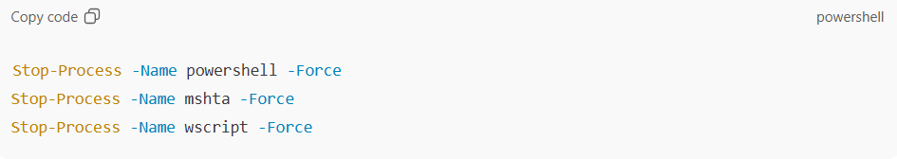
Identify recent scripts executed:
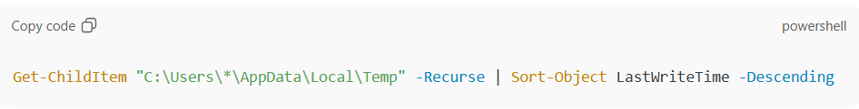
Check autoruns/persistence:
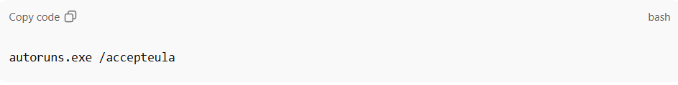

Eradication & Recovery

Eradication
• Remove malware payloads dropped by the attachment.
• Delete scheduled tasks, registry entries, startup folders created by the malware.
• Remove persistence mechanisms (services, WMI subscriptions).
• Scan system with Defender/EDR full scan.
• If RAT or post-exploitation detected → reimage system + reset credentials.

Recovery Steps
• Reset user password, especially if malware included credential theft.
• Re-register MFA (remove old devices).
• Restore damaged files using backups (OneDrive versions, SharePoint versions, organizational backup tools).
• Remove malicious inbox rules if the threat actor gained access.
• Monitor endpoint for abnormal behavior for 48–72 hours.

Evidence to Collect
• Original .eml + attachment files (encrypted ZIP for malware samples).
• SHA256 hashes of attachments and dropped files.
• Sandbox detonation reports (behavior, network traffic, screenshots).
• EDR telemetry:
- Process tree
- Command-line arguments
- Parent-child relationships
• Network logs:
- DNS queries
- HTTP/S requests
- Connections to suspicious IPs
• System artifacts:
- Registry entries
- Scheduled tasks
- Autoruns persistence
• Memory capture (if RAT/traces of C2).
• List of affected endpoints and users.
• TI enrichment reports (VT, URLHaus, MalwareBazaar).

Post-Incident Reporting & Lessons Learned (Metrics, MISP Export)

Lessons Learned
• Identify which attachment types should be blocked at the gateway.
• Strengthen ASR (Attack Surface Reduction) rules for Office macros.
• Review EDR response time and automatic isolation efficiency.
• Improve file-type restrictions for external senders.

Metrics
- Time-to-detonate (sandbox)
- Time-to-containment (endpoint isolation)
- Detection accuracy (sandbox vs EDR)
- Number of impacted endpoints
- Malware execution success rate
- % of users who opened the attachment
- Number of auto-quarantined vs manually quarantined emails

MISP Export
Include:
• File hashes (SHA256, MD5)
• Dropped payload hashes
• C2 IPs/domains
• Sandbox behavioral signatures
• Email sender info
• Malware family identifiers
• Attachments’ metadata
• YARA signatures
• MITRE ATT&CK mapping (Initial Access → Execution → Persistence)
Testing & Exercises (Detection & Training)

Detection Testing
• Test EDR detection for macro-enabled documents.
• Simulate malicious .docm/.xlsm files in sandbox.
• Validate ASR rules blocking Office macros from internet.
• Test SEG file-type filtering policies.
• Trigger simulated C2 traffic in controlled lab environment.

Training & Campaigns
• Conduct phishing simulations using “Invoice.docm”, “Payment.xlsm”, “Resume.pdf”.
• Train employees to NEVER enable macros unless validated by IT.
• Create awareness campaigns about malicious ZIP/RAR attachments.
• Host tabletop exercises simulating malware spreading from a user opening a file.
• Red-team scenarios mimicking real malware families (Qakbot/Emotet initial infection).

What is Business Email Compromise (BEC) / Payment Fraud Phishing?
Business Email Compromise (BEC), also known as Email Account Compromise (EAC), is a sophisticated type of phishing attack where cybercriminals impersonate trusted sources—such as executives, employees, vendors, attorneys, or business partners—to trick victims into making fraudulent wire transfers, disclosing sensitive data, or approving unauthorized payments. Unlike general phishing, which often includes malicious links or attachments, BEC relies heavily on social engineering and email spoofing to exploit trust, urgency, and authority, resulting in significant financial losses (over $2 billion annually in the U.S. alone). Payment fraud phishing specifically targets financial transactions, such as invoice manipulation or requests to update banking details, often by hijacking legitimate email threads or creating lookalike domains. These attacks are targeted rather than mass-distributed, making them harder to detect with traditional antivirus tools.
Indicators of Compromise (IoCs) for BEC Phishing
Indicators help identify potential BEC activity early. Common signs include unusual email language, account anomalies, and technical red flags. Here's a summarized list based on key red flags:
Indicator | Description
Spoofed Domains | Near-identical domains (e.g., "your-company.com" vs. "yourcompany.com") using typosquatting, homographs (lookalike characters), or subtle variations; emails lack attachments/links.
Spoofed Display Names | Emails appear from familiar names (e.g., "CEO John Smith") but use unrelated sender addresses like Gmail; often include urgent requests.
Unusual Account Behavior | Activity from legitimate accounts at odd hours, to unfamiliar recipients, or with tone shifts, indicating compromise via phishing/malware.
Urgent Requests for Confidential Information | High-pressure language like "urgent," "ASAP," or "immediate," with deadlines and instructions against verification.
Inconsistent Communication Style | Changes in tone, grammar, phrasing, or formatting (e.g., formal sender using casual slang).
Anomalous Sending Behavior | Emails sent at unusual times, from odd locations, or in high volumes inconsistent with normal patterns.
Mismatched Sender Addresses | Familiar names with unfamiliar domains, including lookalikes or punctuation swaps.
Fraudulent Payment Requests | Urgent demands to wire funds to new accounts, often impersonating vendors/executives.
Spoofed Email Threads | Insertion into ongoing conversations, mimicking style and referencing details.
Missing External Email Warnings | No banners/tags for external messages, making them appear internal via manipulation.
Suspicious Attachment Types | Unusual files like .zip, .rar, or macro-enabled docs with urgent open instructions.
Malicious Redirected Links | Hidden destinations using trusted services or multi-level redirects to phishing sites.
Additional indicators: Fake prospective customers from overseas, geo-tagged anomalies (rare), or engagement filters like min_faves in advanced searches.
Triage Checklist
Triage involves initial assessment to confirm and scope the incident. Use this checklist:
- Log a ticket and acknowledge user reports of suspicious emails.
- Review email details (headers, URLs, attachments) for anomalies.
- Interview impacted users for context (e.g., credential entry on fake sites, unexpected documents).
- Search for IoCs like phishing emails, malware hashes, or unusual logins (IPs, concurrent sessions).
- Assess victim accounts and related sources (e.g., OneDrive, SharePoint) for sensitive data exposure; consult legal.
- Check for other victims in the environment using IoCs.
- Determine compromise method (e.g., phishing, malware) and gather evidence.
- Report to authorities if financial loss (e.g., FBI at IC3.gov).
Containment Strategies (Automated vs. Manual + Specific Commands per Tool)
Containment aims to stop the attack's spread. Automated methods use tools for quick blocking; manual requires hands-on intervention.
Automated Containment
- Block IoCs (e.g., URLs, domains, hashes) in email filters, spam tools, and endpoint protection (e.g., via antivirus like Microsoft Defender or third-party EDR).
- Use behavioral analysis tools for auto-isolation of threats (e.g., endpoint detection and response (EDR) systems like CrowdStrike or Palo Alto to quarantine based on anomalies).
Manual Containment
- Microsoft 365/Exchange Online (PowerShell Commands):
  - Disable account: Install-Module Microsoft.Graph; Connect-MgGraph -Scopes "User.ReadWrite.All"; Get-MgUser -Search UserPrincipalName:'<UPN>'; Update-MgUser -UserId $user.Id -AccountEnabled $false.
  - Revoke sessions: Install-Module Microsoft.Graph.Users.Actions; Connect-MgGraph -Scopes User.RevokeSessions.All; Revoke-MgUserSignInSession -UserId <UPN>.
  - Check/remove forwarders: Connect-ExchangeOnline; Get-Mailbox -Identity <Identity> | Format-List Forwarding*Address,DeliverTo*.
  - Check/remove inbox rules: Get-InboxRule -Mailbox <Identity> -IncludeHidden | Format-List; Disable-InboxRule or Remove-InboxRule -Identity <RuleID>.
- Isolate devices: Disconnect from network; preserve for forensics (no power-off unless critical).
- Notify externals/legal; block domains in email gateway.
Eradication & Recovery (Including Password Resets, MFA Enforcement, Mailbox Restore)
Eradication
- Remove suspicious rules/delegations/apps: Use above PowerShell to delete; revoke OAuth consents and unauthorized MFA methods.
- Scan/rebuild systems: Full malware scans; replace infected endpoints after preserving data.
- Enable Litigation Hold: In Microsoft 365, activate on mailbox to preserve data.
Recovery Steps
- Password resets: Use strong passwords (upper/lower, numbers, specials); reset twice for synced AD; avoid emailing; update federated accounts on-premises.
- MFA enforcement: Enforce on reset; remove suspicious methods/devices; use browser-native or hardware keys to prevent AiTM bypass.
- Mailbox restore: Use tools like Acronis for one-click rollback; reset password/enable account post-investigation (Update-MgUser -UserId $user.Id -AccountEnabled $true). Monitor for anomalies.
- Remediate vulnerabilities; consult insurance for losses.
Evidence to Collect
Collect for forensics, legal, and reporting:
- Malicious emails, malware samples (password-protected storage; hashes via PowerShell Get-FileHash).
- Logs: Microsoft Entra sign-ins (IPs, locations, times), Azure audit logs, Defender portal audits (filter by date/activity).
- Systems/artifacts: Forensic images, VM snapshots, memory dumps; sent emails, shared files (OneDrive/SharePoint), OneNote/Teams changes.
- IoCs: URLs, domains, login anomalies, new users.
- Analyze via tools like VirusTotal or Hybrid-Analysis.
Post-Incident Reporting & Lessons Learned (Metrics, MISP Export)
Post-incident focuses on analysis and improvement:
- Conduct debrief: Discuss what went well/not; identify gaps (e.g., training, patching, MFA); plan remediations like updated policies.
- Metrics: Track incident duration, financial impact, detection time, response effectiveness (e.g., % of IoCs blocked), employee reporting rates.
- Reports: Technical for CSIRT; executive summary for management; include timeline, root cause, recommendations.
- MISP Export: Use MISP (Malware Information Sharing Platform) to export IoCs (e.g., events, attributes like IPs, hashes) for sharing; supports manual/automated input, Markdown reports, and integrations like Azure Sentinel.
Testing & Exercises (Detection & Training)
To prepare, conduct regular testing and training:
- Employee Training: Cover BEC basics, indicators (e.g., urgency, spoofing); use interactive sessions with real-world examples; focus on roles (e.g., finance for payment requests).
- Simulations/Drills: Run phishing simulations (e.g., AI-crafted scenarios like deepfake CEO requests or BEC invoice changes); track click rates and report metrics.
- Tabletop Exercises/Red Teaming: Simulate full incidents; test response playbooks with stakeholders; assess detection tools (e.g., email gateways, EDR).

Reply-Chain Compromise / Forwarded Internal Thread
Overview
A reply-chain compromise is an advanced email-based social engineering attack in which an adversary gains access to a mail account, reviews existing internal email threads, and then replies within an existing conversation to deliver a malicious payload or phishing URL. This significantly increases credibility and bypasses typical user suspicion.
Indicators of Compromise (IoCs)
- Unexpected reply within an old internal thread
- New URL or attachment inserted into an otherwise normal email chain
- Login attempts from unusual geolocations
- Sudden creation of inbox rules (forward/move/delete)
- Outbound email spikes from the compromised user
- Deleted Sent Items or unusual mailbox cleanup
Triage Checklist
- Collect full message (.eml) including all headers
- Compare the malicious reply to previous thread messages
- Extract and analyze URLs (including redirects)
- Review Azure AD sign-in logs for suspicious authentication
- Check inbox rules and forwarding configurations
- Identify other recipients who received or interacted with the message
Containment (Manual & Automated)
Automated:
- Auto-purge the malicious email
- Block malicious URLs/domains via SEG and proxy
- Trigger SOAR workflows for account lockdown
Manual:
- Disable account temporarily
- Revoke all active sessions
- Remove malicious inbox rules
- Purge message from all mailboxes
Evidence to Collect
- Full email (.eml) + headers
- Mailbox audit logs
- Sign-in logs (IPs, MFA events)
- Browser/proxy logs
- URL chain analysis results
- OAuth app list
Eradication & Recovery
- Reset compromised user password
- Revoke refresh tokens
- Enforce MFA re-registration
- Remove malicious forwarding rules
- Restore mailbox items if deleted
Post-Incident Reporting & Lessons Learned
Metrics:
- Time to Detect (TTD)
- Time to Contain (TTC)
- Number of impacted users
- Sender/recipient patterns
MISP Export:
- Sender IP
- URLs
- Hashes
- Email metadata
Testing & Exercises
- Simulated internal reply-chain phishing campaigns
- Tabletop exercises for thread hijacking
- SOC detection rule validation

Multi-Stage (Stager URL → Redirect → Credential Form → Exfiltration)
Overview
A multi-stage phishing attack uses a sequence of redirects to evade detection. The attacker sends a stager URL → that redirects to an intermediate site → ultimately landing on a fake credential form → which exfiltrates credentials to a command-and-control endpoint.
Indicators of Compromise (IoCs)
- Shortened or obfuscated URLs
- Multiple redirect hops
- Fake Microsoft/Okta/VPN login pages
- Base64/encoded email address in URL
- Newly registered or low-reputation domains
- Proxy logs with outbound requests to unknown endpoints
Triage Checklist
- Preserve the malicious email (.eml)
- Extract the URL and analyze each redirect hop
- Determine if the user entered credentials
- Review sign-in logs for impossible travel or unfamiliar devices
- Check inbox rules and OAuth apps
- Identify additional users who clicked the URL
Containment (Manual & Automated)
Automated:
- Auto-quarantine emails matching stager URL
- URL/domain block via SEG and SWG
- Risk-based policy triggers on suspicious MFA/login
Manual:
- Disable user account
- Revoke all sessions
- Block all domains in redirect chain
- Purge email from all inboxes
Evidence to Collect
- Full redirect chain
- HTML source of final phishing page
- JavaScript and exfil endpoints
- Proxy traffic logs
- Authentication logs (MFA, device, token usage)
- Cookies/tokens in case of AiTM
Eradication & Recovery
- Reset user password
- Revoke tokens
- Enforce MFA reset
- Remove OAuth malicious applications
- Validate conditional access rules
Post-Incident Reporting & Lessons Learned
Metrics:
- Number of redirects
- Click rate
- Credential submission count
- Block effectiveness
MISP Export:
- Stager URL
- Redirect domains
- Exfil servers
- Phishing kit artifacts
Testing & Exercises
- Multi-stage phishing simulations
- Redirect-blocking tests via proxy
- SOC detection testing for anomalous login behavior

